Term 3 Sharing topics
Dear Parents/ Caregivers,
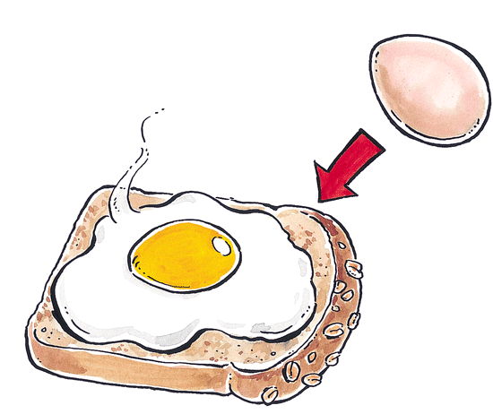
Here is the list of topics for Sharing in Term 3. Many relate to our Inquiry Unit- “Spot the difference”. As part of the Listening and Speaking skills development the students will be assessed on their presentations.
Thank you Renee Fisher
Week | Topic
1 | My Holidays
2 | What are some foods in your house that change eg: how food changed when it was raw then cooked, heated then cooled, room temperature then frozen.
3 | Draw a picture of food and what it looks like when it changes eg: frozen- ice, melted- water OR uncooked- bread, cooked- toast.
4 | What is your favourite recipe to cook with your family?
5 | Book Week: What’s your favourite story? Why do you like it?
6 | How do you make someone you love feel special?
7 | If you could create a show bag for The Royal Adelaide Show, what would it be called and what would be in it?
8 | This year is the year of the Clean and Healthy Planet.  What do you do to keep our planet healthy?
9 | What have you learnt from the inquiry topic “Spot the difference”?
10 | Free choice

