**Term 4 Sharing topics**

Dear Parents/ Caregivers,

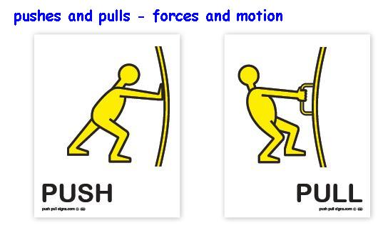 Here is the list of topics for Sharing in Term 4. Many relate to our Inquiry Unit- *“Fantastic Forces”*. As part of the Listening and Speaking skills development the students will be assessed on their presentations.

C:\Program Files\Microsoft Office\Media\CntCD1\ClipArt3\j0238193.wmfThank you Renee Fisher

|  |  |
| --- | --- |
| **Week** | **Topic** |
| **1** | My holidays |
| **2** | Tell us some facts about your favourite animal or sea creature. |
| **3** | Bring in a toy and tell us how it work by either pushing or pulling. |
| **4** | Make a list of things in your home that work by push or pull. |
| **5** | Share a simple celebration/ or Christmas craft. It could be something you made last year. |
| **6** | What is your favourite story? It could be your favourite Christmas story |
| **7** | Share a special holiday or Christmas memory |
| **8** | My summer holiday plans |
| **9** | Free choice |

**Term 4 Sharing topics**

Dear Parents/ Caregivers,

 Here is the list of topics for Sharing in Term 4. Many relate to our Inquiry Unit- *“Fantastic Forces”*. As part of the Listening and Speaking skills development the students will be assessed on their presentations.

C:\Program Files\Microsoft Office\Media\CntCD1\ClipArt3\j0238193.wmfThank you Renee Fisher

|  |  |
| --- | --- |
| **Week** | **Topic** |
| **1** | My holidays |
| **2** | Tell us some facts about your favourite animal or sea creature. |
| **3** | Bring in a toy and tell us how it work by either pushing or pulling. |
| **4** | Make a list of things in your home that work by push or pull. |
| **5** | Share a simple celebration/ or Christmas craft. It could be something you made last year. |
| **6** | What is your favourite story? It could be your favourite Christmas story |
| **7** | Share a special holiday or Christmas memory |
| **8** | My summer holiday plans |
| **9** | Free choice |